Lab Task # 01: String Library

Take an input sentence (maximum length N = 100) and perform the following operations on the sentence using functions. Prepare string.h and string.cpp as library files and use that library in main.

- Length of the sentence
- Sentence in lowercase
- Sentence in uppercase
- Number of words in the sentence
- Number of vowels
- Frequency of the vowels

Flow Chart: 20 Minutes Code: 20 Minutes

Scientific Computing - Linear Algebra Library
At the core of all scientific computations for nuclear simulation, weather modeling or circuit simulation is linear algebra. In linear algebra, there are typically three levels of operations that are the most common which usually involve arrays. You need to create a linearalgebra.h and linearalgebra.cpp for this library.
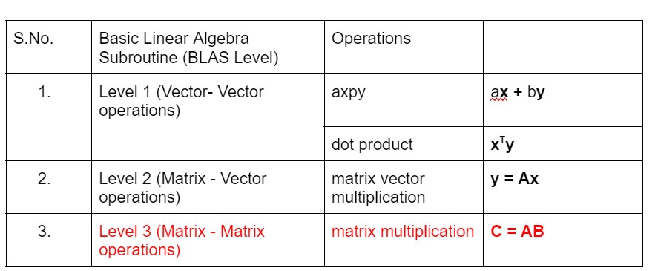

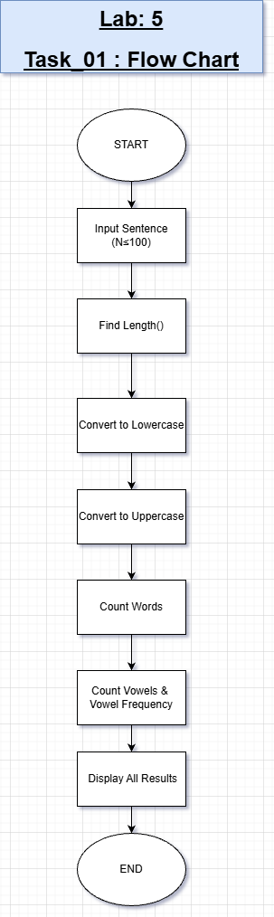
FLOWCHART

OUTPUT

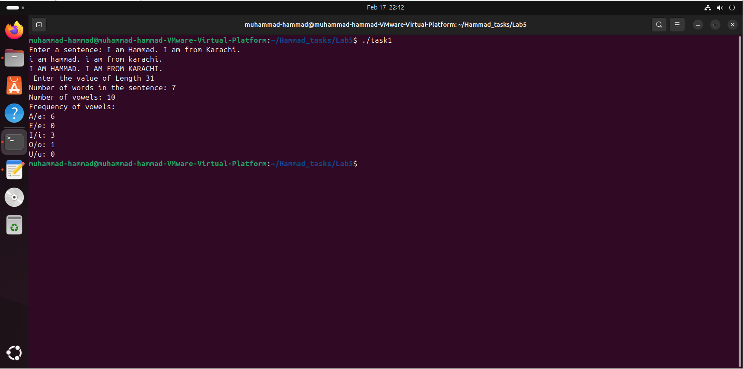
Task #01 – String Library

In this task, a sentence of maximum length 100 is taken as input and different operations are performed using separate functions. These include finding the length, converting the sentence to lowercase and uppercase, counting words, vowels, and the frequency of each vowel. It mainly focuses on modular programming and using multiple files like header and source files.

Lab Task # 02
Level 1 Operations - x^{T}y
Write a function which takes inputs x and y from the user (x, y are vectors of size N). Your program should then compute the dot product.
Flow Chart: 15 Minutes Code: 15 Minutes
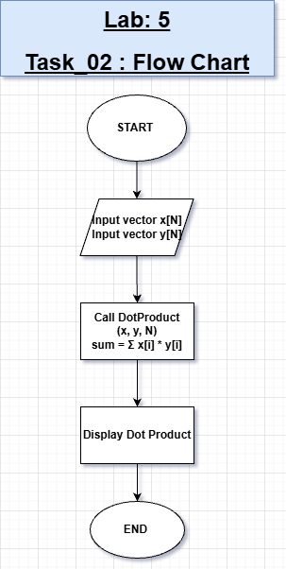

FLOWCHART
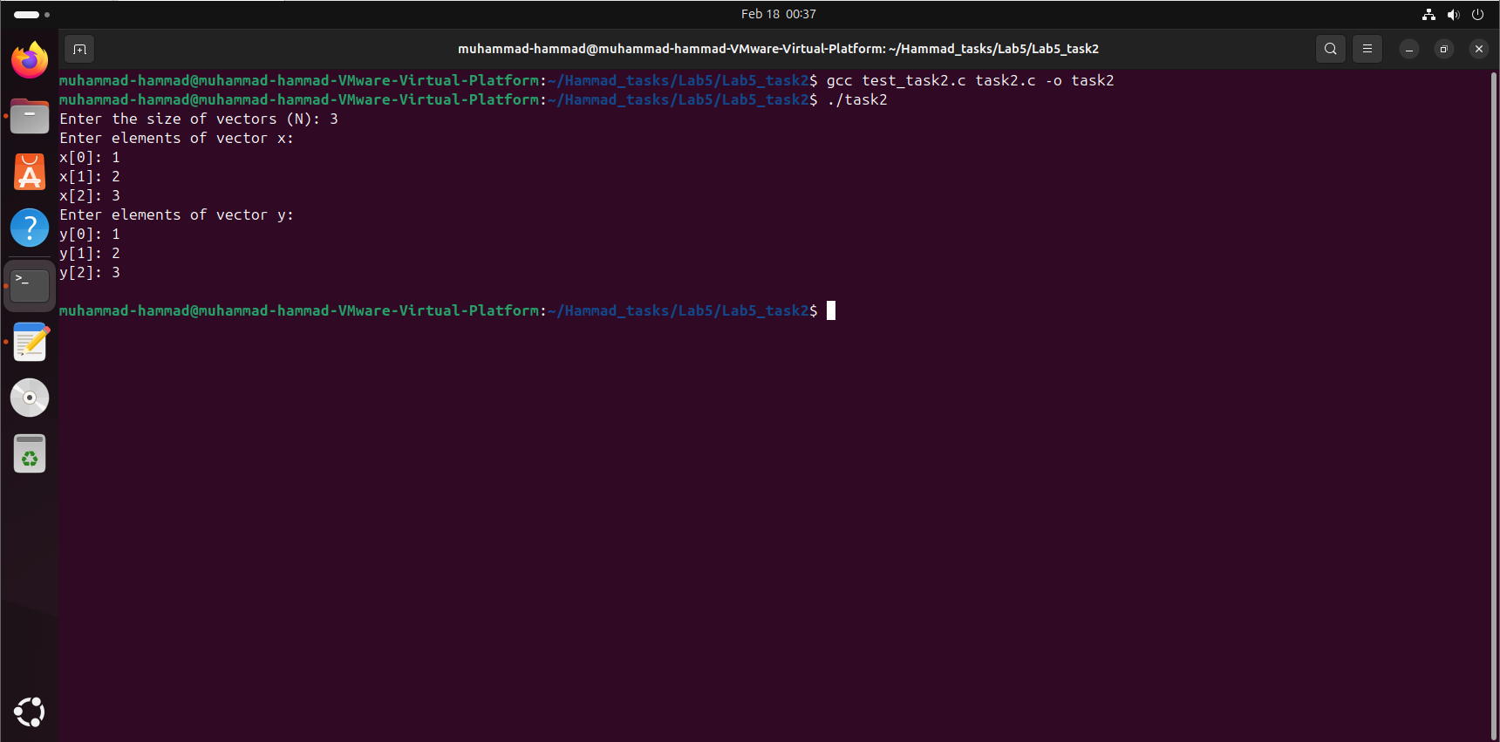
OUTPUT
Task #02 – Level 1

Operation (xᵀy – Dot Product)

This task involves taking two vectors of size N from the user and computing their dot product using a function. It introduces basic linear algebra operations and emphasizes function reuse and clean code structure. The implementation also strengthens understanding of arrays and loops.

Lab Task # 03
Level 2 Operations - Matrix Vector Multiply (y=Ax)
Write a function which takes inputs A and x from the user (A is of size M x N, x is of size Nx1) and compute the matrix vector multiplication. You should reuse dot products in this function.
Flow Chart: 30 Minutes Code: 30 Minutes

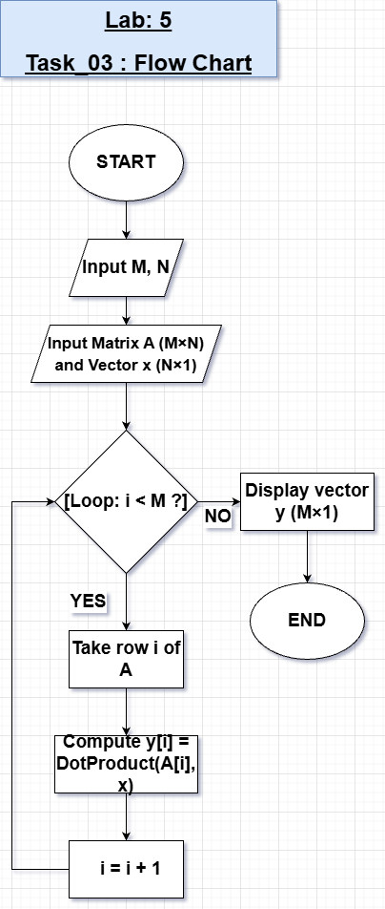
FLOWCHART

OUTPUT

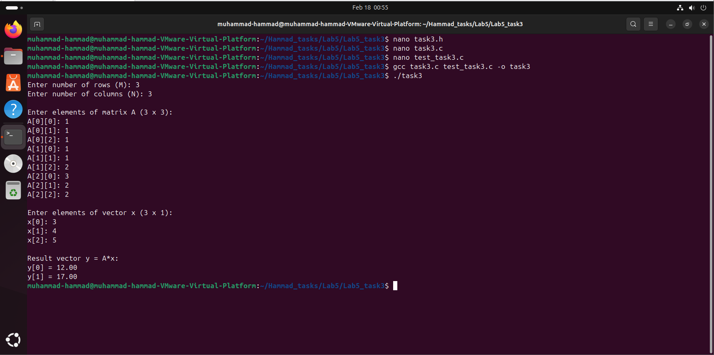
Task #03 – Level 2 Operation (Matrix Vector Multiply y = Ax)

In this task, a matrix A of size M×N and a vector x of size N×1 are used to compute the matrix-vector multiplication. The dot product function from the previous task is reused to perform row-wise calculations. This highlights the concept of code reusability and modular design in scientific computing.

Lab Task # 04
Level 3 Operations - Matrix Vector Multiply (C=AB)
Write a function which takes inputs A and B from the user (A is of size M x N, B is of size NxK) and compute the matrix matrix multiplication. You should reuse dot products in this function. You might have to take transpose of B.
Flow Chart: 30 Minutes Code: 30 Minutes

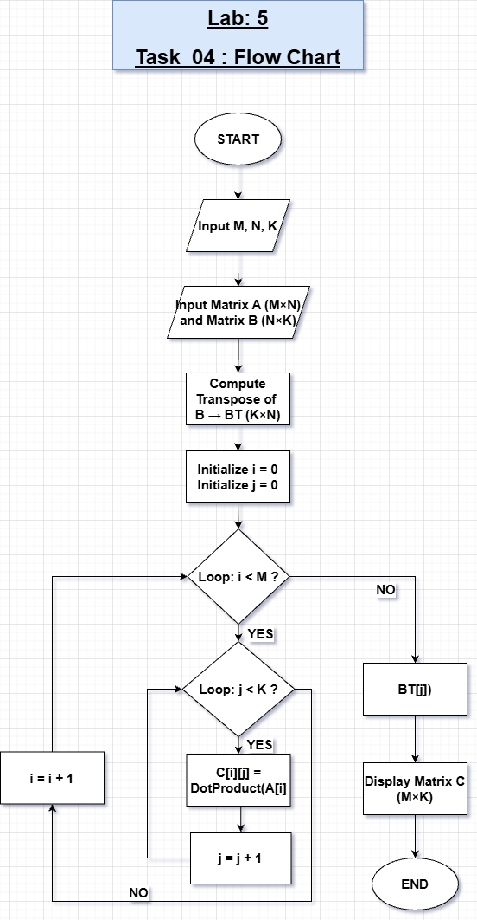
FLOWCHART

OUTPUT
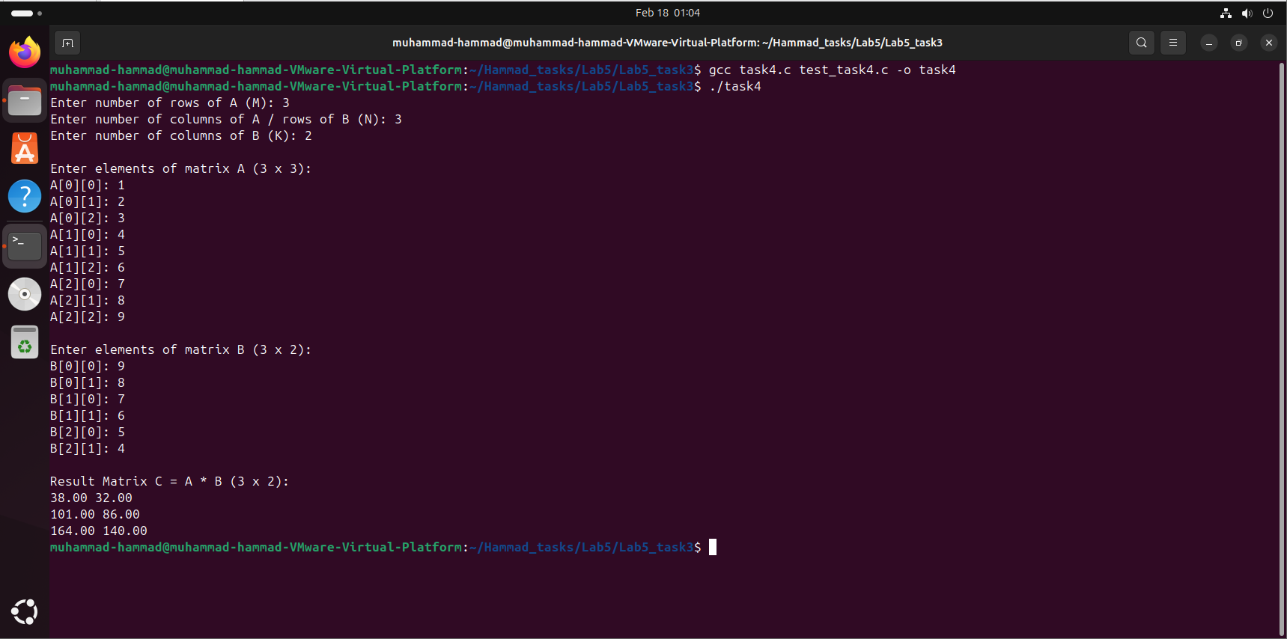
Task #04 – Level 3 Operation (Matrix Multiplication C = AB)
This task extends linear algebra operations to matrix-matrix multiplication where A is M×N and B is N×K. The result matrix C is obtained by reusing the dot product function, often by taking the transpose of matrix B. It demonstrates higher-level operations and efficient implementation using functions and multiple files.

Signal Processing Library

Lab Task # 05

Write a signal processing library to carry out the following functions. Your signal will be an array of floats.
- Find average value of the signal
- Detect number of zero crossings in the signal
- Detect number of glitches in the signal
- Filtering of the signal with a given transfer function (size of signal and transfer function will be fixed)

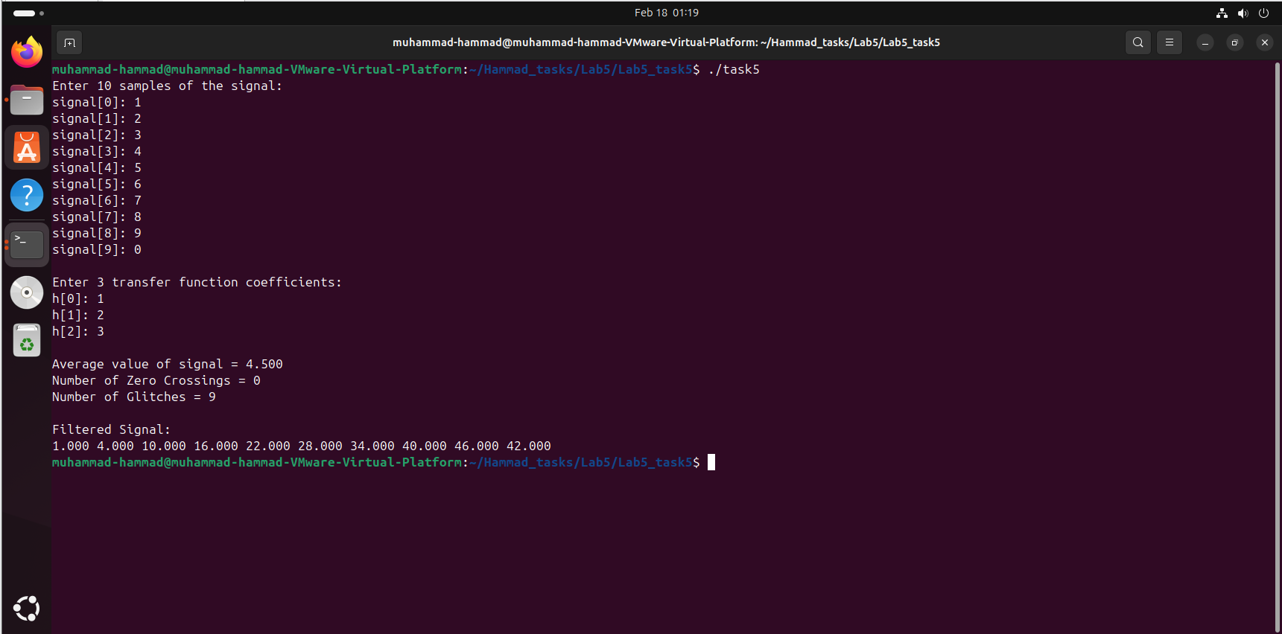
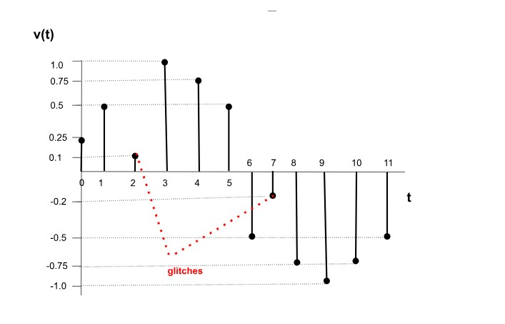
OUTPUT
Task #05 – Signal Processing Library
In this task, a signal represented as a float array is processed using different functions. The operations include calculating the average value, detecting zero crossings, identifying glitches, and filtering the signal using a given transfer function. It provides practical exposure to basic digital signal processing concepts.

FLOWCHART
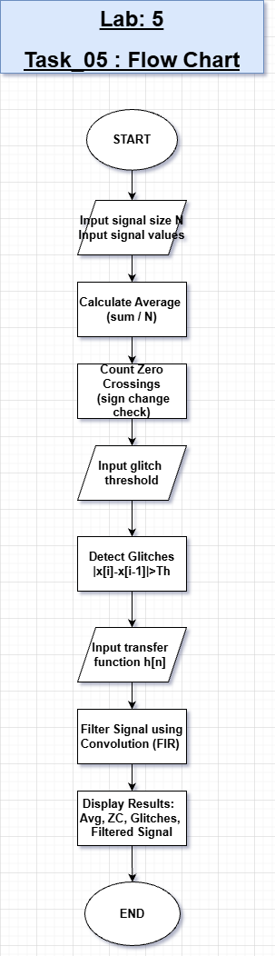

Image Processing Library

Task #06:
Write an image processing library to carry out the following functions. Your image will be a 3D array containing RGB values.
- Find the type of pixels in the image. Your function should take pixel type as input (0 — black, 1 - white, 2 - yellow)
- Perform RGB to GrayScale conversion
- Perform convolution on the 2D grayscale image with following filter

H = [ 1 1 1 ; 1 1 1; 1 1 1]/9;

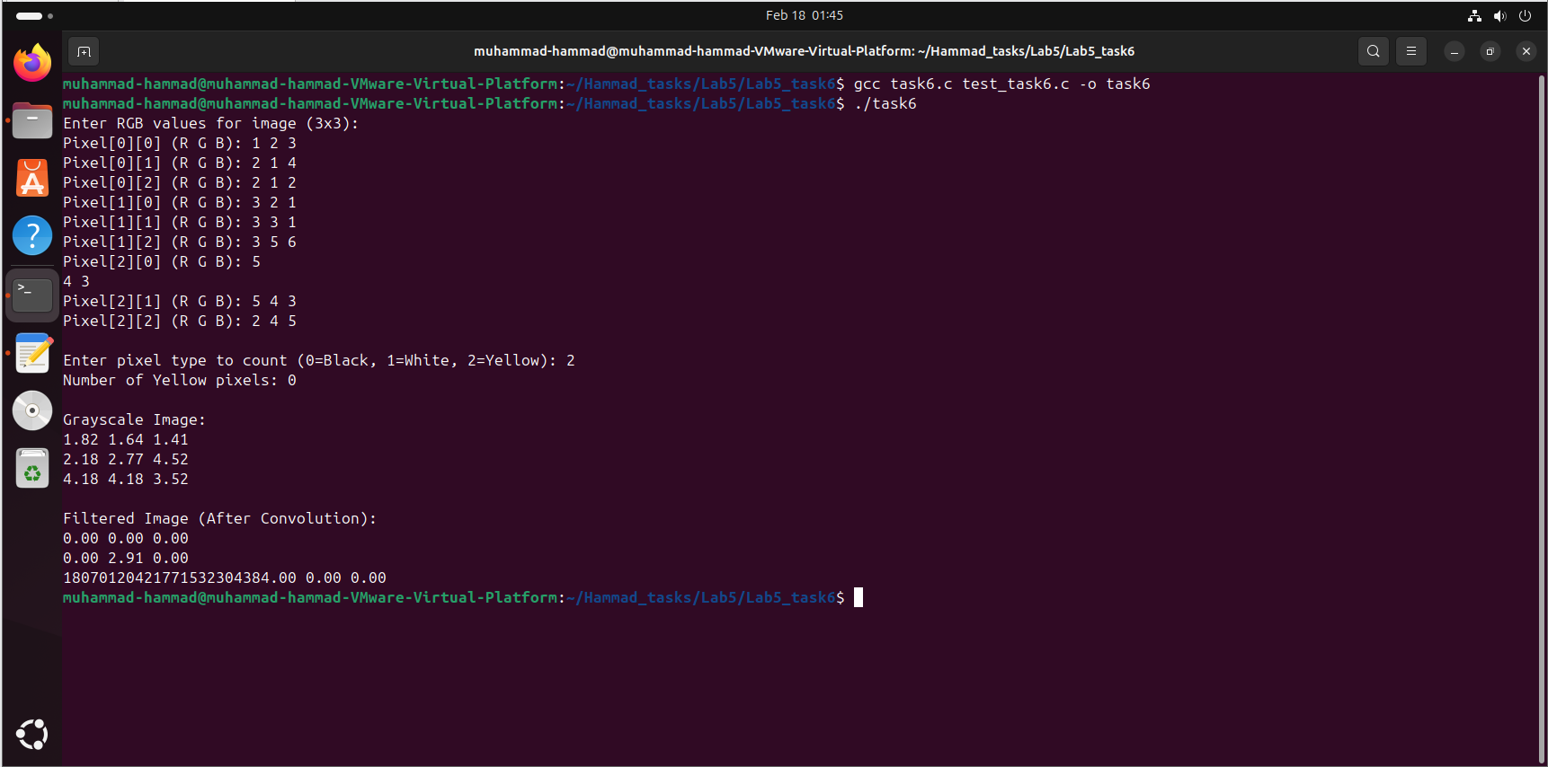
OUTPUT
Task #06 – Image Processing Library
This task works with a 3D RGB image array and performs multiple image processing operations. It includes detecting pixel types (black, white, yellow), converting RGB images to grayscale, and applying a 3×3 convolution filter. The task mainly focuses on handling multidimensional arrays and implementing image processing techniques through functions.

FLOWCHART

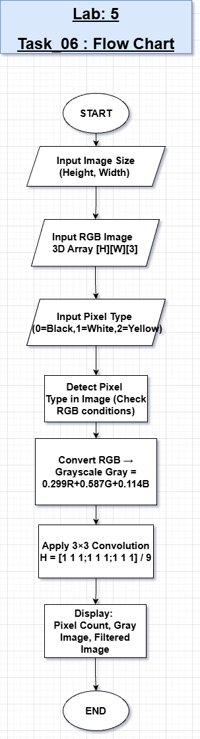

CONCLUSION:
This lab provided a strong understanding of functions, multiple file handling, and modular programming. It covered core concepts of string processing, linear algebra, signal processing, and image processing in a structured way. Overall, the tasks improved problem-solving skills and demonstrated how reusable functions can be used to build efficient and organized libraries in C/C++.

